GIT Branching

22. Create an empty directory ‘Assignments’ and cd to ‘Assignments’ and cd to ‘assignments’.



23. create a file readme..txt inside ‘assignments’ and write few lines about the contents of ‘assignments’ folder

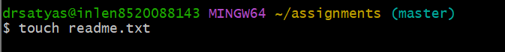

24. commit readme.txt file.

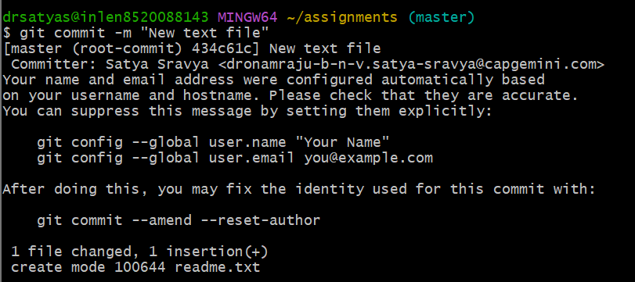

25. now create a new branch ‘html-assignments’.



26. switch to ‘html-assignments’

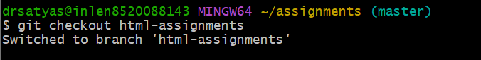

27. copy all HTML assignments inside ‘assignments’ folder

28. Commit HTML assignments into ‘html-assignments’ branch

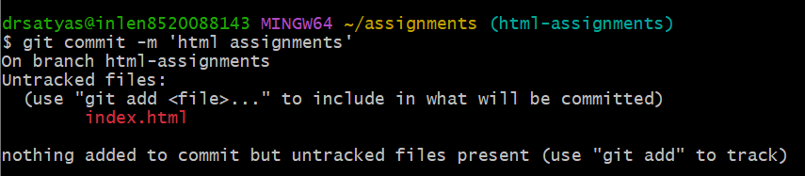

29. make minor changes into few files belonging to ‘html-assignments’ branch.

30. commit those changed files.

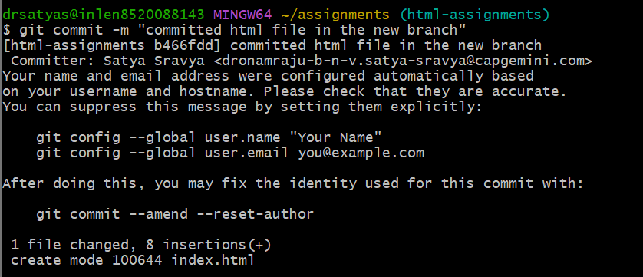

31. switch to master branch.

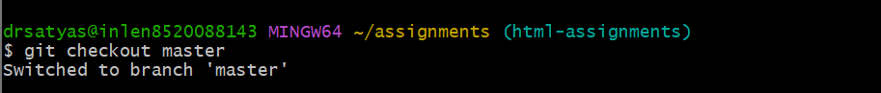

32. make minor changes into readme.txt file and commit those changes into master.

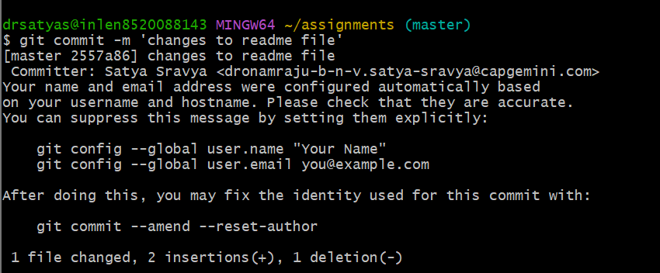

33. again switch to ‘html-assignments’ branch

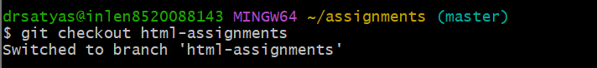

34. make minor changes into few files belonging to ‘html-assignments’ branch.

35. commit those changes

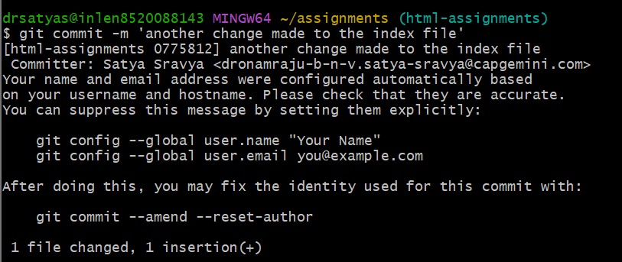

36. switch to master

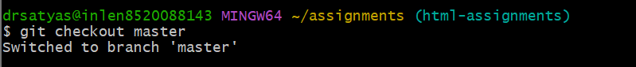

37. merge ‘html-assignments’ branch into master. Confirm all html-assignments are shown in master.

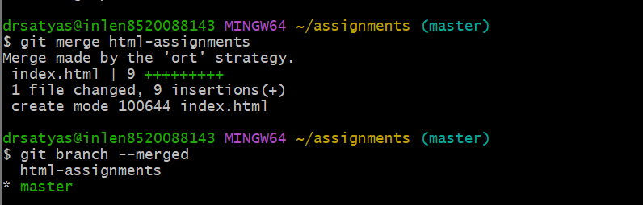

38. finally delete the ‘html-assignments’ branch.

